EXP NO:7A | DATA VISUALIZATION USING TABLEAU

Aim:
To connect, analyze, visualize, and create interactive dashboards using Tableau for effective business intelligence and data analytics.

Algorithm:

Algorithm: Student Performance Visualization using Tableau Step 1: Data Loading
- Connect the synthetic Student Performance dataset to Tableau.
- Verify the imported fields: Student, Department, and Marks.
- The dataset contains six students: Arun, Bala, Divya, Priya, Ravi, and Karthik.

Step 2: Student Marks Bar Chart
- Create a worksheet for student-wise marks.
- Place Student on Columns.
- Place Marks on Rows.
- Select the Bar Chart visualization.
- Enable data labels to display the marks of each student.

Step 3: Department-wise Marks Visualization
- Create a worksheet using Department and Marks.
- Aggregate Marks using SUM.
- Visualize the contribution of each department using a Pie Chart.
- Display department names and corresponding marks as labels.

Step 4: Student Performance Trend
- Create a Line Chart using Student and Marks.
- Place Student on Columns and Marks on Rows.
- Enable labels to display individual marks.
- Use the chart to compare the performance of students.

Step 5: Marks Percentage
- Create a calculated field named Percentage.

- Use the formula: [Marks]
- Display Student, Marks, and Percentage in a worksheet.

Step 6: Department Filter
- Add Department to the Filters shelf.
- Select a department such as AI&DS.
- Observe the updated student marks based on the selected department.

Step 7: Minimum Marks Parameter
- Create a parameter named Minimum Marks.
- Set the required minimum marks value.
- Apply the parameter to display only students whose marks meet or exceed the selected value.
- For example, when Minimum Marks = 85, display students scoring 85 or above.

Step 8: Dashboard Creation
- Create a new Tableau Dashboard.
- Add the Student Marks, Department Contribution, Marks Percentage, Student Performance Trend, and Minimum Marks visualizations.
- Arrange the worksheets clearly.
- Add the Department filter and Minimum Marks parameter.
- Format the dashboard with suitable titles and labels.

Step 9: Story Creation
- Create a Tableau Story using the completed dashboard.
- Add story points for:
  - Overall Student Performance
  - Department-wise Analysis
  - Top Performing Students
  - Final Performance Analysis
- Present the visual insights using the story.

Step 10: Analysis
- Analyze the charts to identify the highest and lowest performing students.
- Compare marks among departments.
- Observe how the Department filter and Minimum Marks parameter dynamically change the visualizations.
- Use the dashboard and story to summarize the overall student performance.

Output:
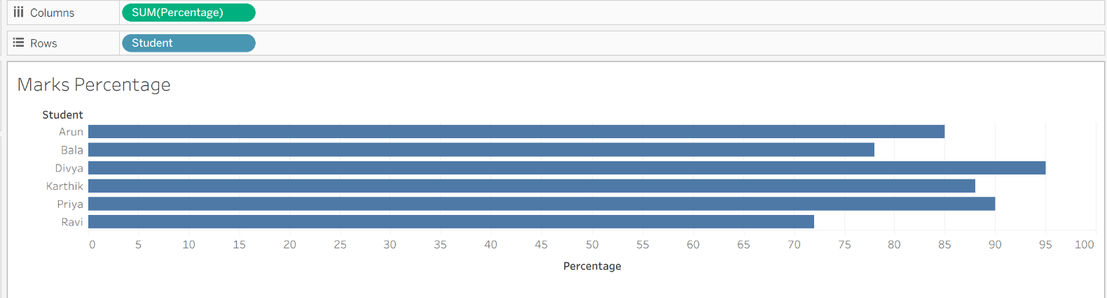

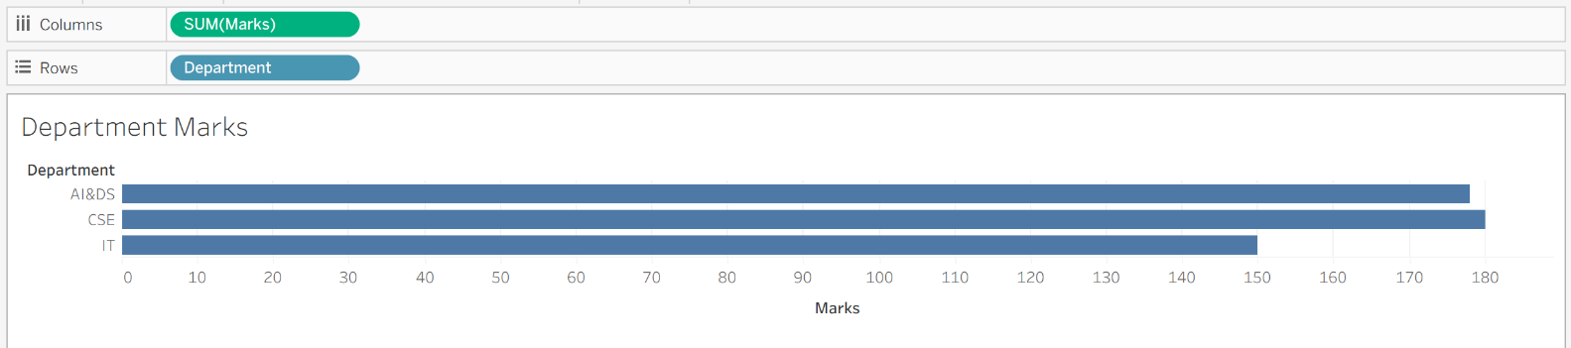
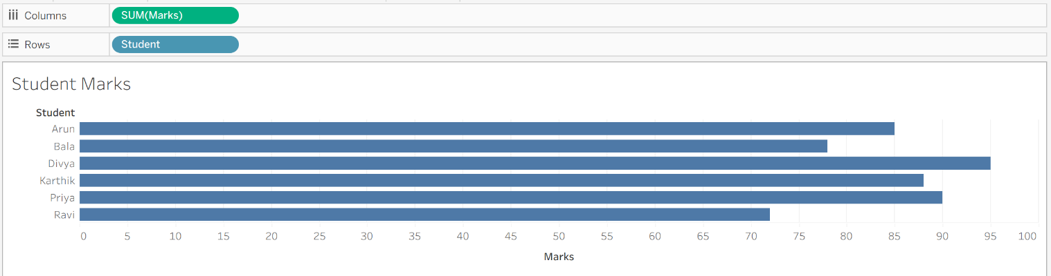

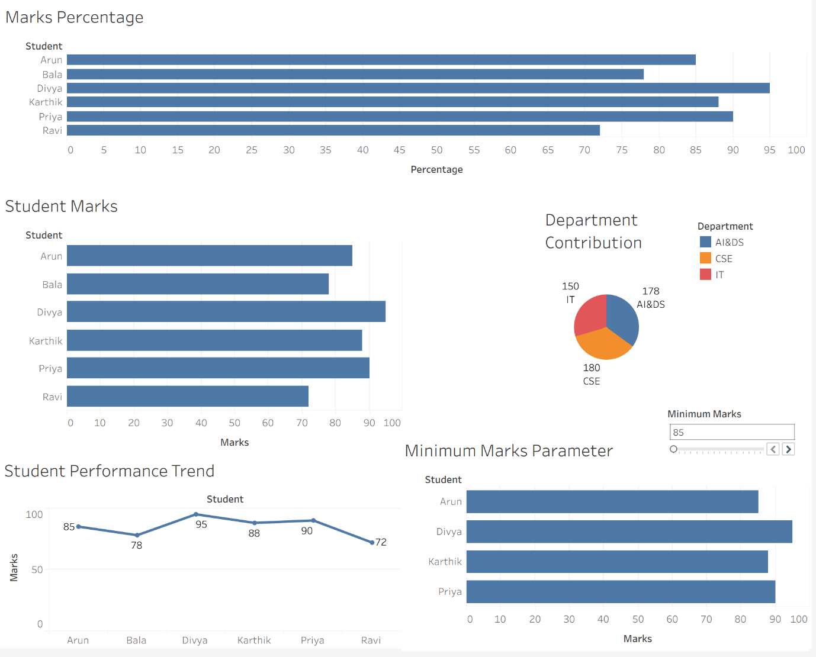

Result:

EXP NO:7B | DATA VISUALIZATION USING TABLEAU

AIM:
To import, transform, analyze, and visualize the Space Mission dataset using Tableau Desktop and create interactive worksheets and dashboards to analyze space missions based on organisations, mission status, launch year, locations, and prices.

ALGORITHM:
- Start.
- Open Tableau Desktop.
- Connect to the Space Mission CSV dataset using Connect → Text File.
- Import and verify the dataset and its fields.
- Clean and transform the data by handling missing values, correcting data types, and removing duplicate records if required.
- Open a new Worksheet and select suitable fields for visualization.
- Create a Bar Chart to compare organisations based on the number of space missions.
- Create a Pie/Donut Chart to display the distribution of missions based on Mission Status.
- Create a Line Chart to analyze the number of space missions over the launch year.
- Create a Table to display important mission information such as organisation, number of missions, average price, and mission status.
- Create suitable Calculated Fields such as average mission price for detailed analysis.
- Add Filters for fields such as Organisation, Rocket Status, and Year to make the visualizations interactive.
- Combine the worksheets to create an interactive Tableau Dashboard.
- Stop.

OUTPUT:

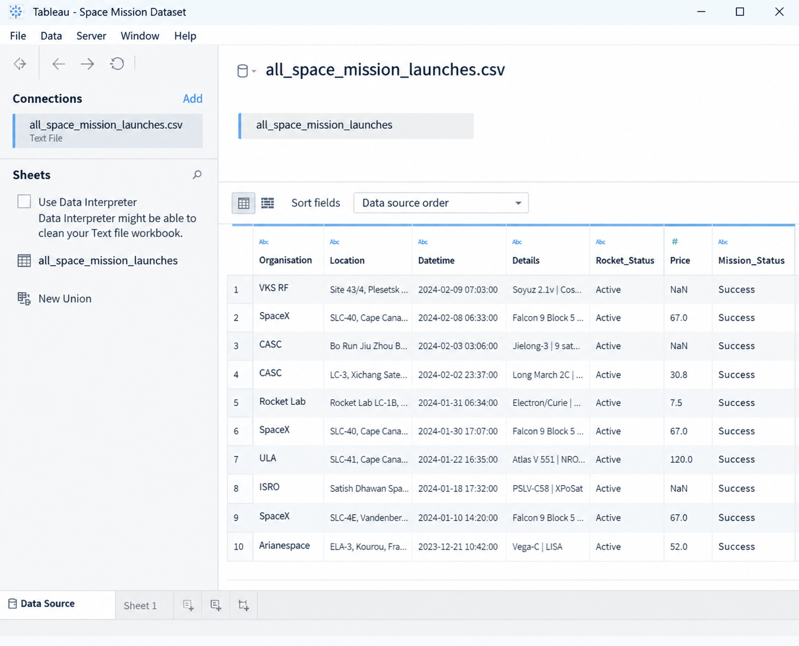

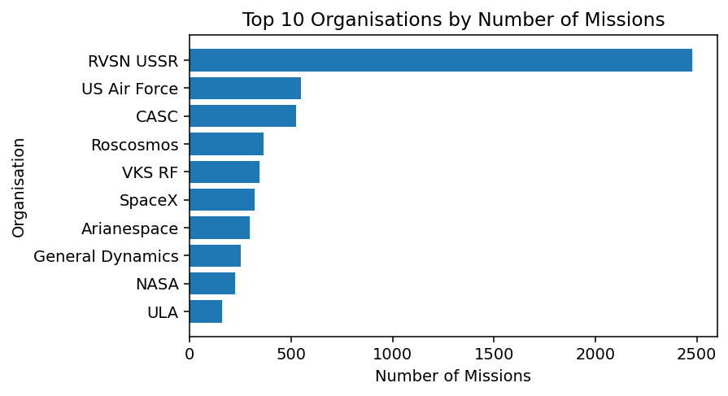

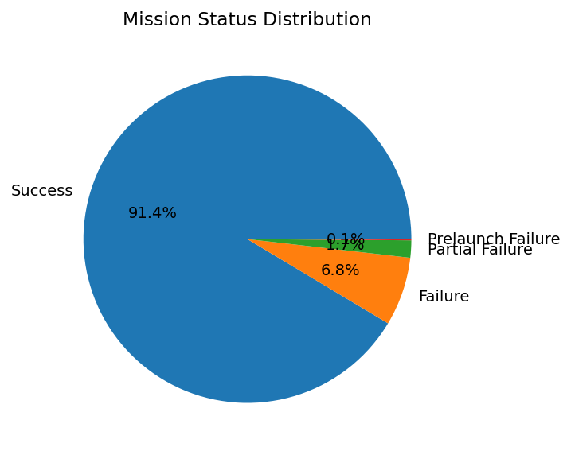

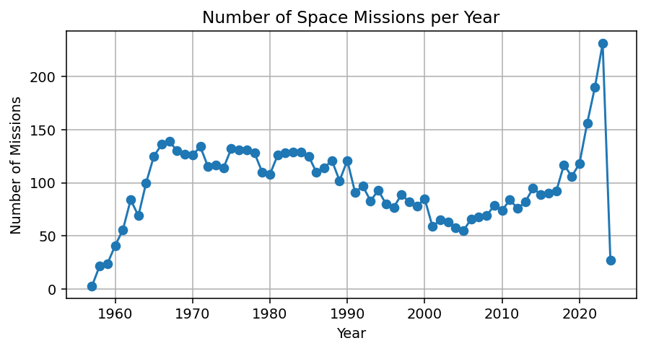

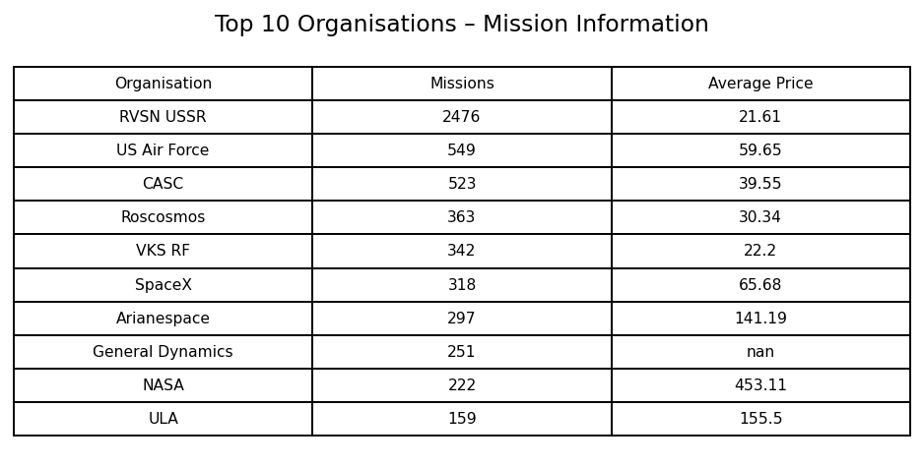

Result:

